1. We do not need to give a suggestion about the amount of money wagered on the Bonus Bet. True?
2. Bonus Bet: As this bet is resolved before the playing decision is made, this should not impact the player strategy. It only affects the expected value, variance and the total house or player advantage of this gave. Because those are from two bets, Ante Bet and Bonus Bet. We caculate the expected value, and variance per initial Ante Bet and Bonus Bet, and then add them up to get total ones, i.e. Total expected value= EA\*# of Ante + EB\*# of Bonus. Variance can also be added up because of independence. And we already know that house (player) advantage is defined per initial bet. So in this game, the advantage should be defined per initial Ante and Bonus Bet.

True?

1. Is this optimal strategy OK?

Denote $X_{1}, X_{2}$ as the player’s hole cards, $X_{3}, X_{4}, X_{5}$ as three cards at flop, $X_{6}$ as turn card, $X_{7}$ as river card, and ${Y=(Y}_{1}, Y_{2})$ as the dealer’s hole cards.

Under standard condition, the dynamic strategy is derived retrospectively as below:

1. For fixed $x_{1}, x_{2}, x_{3}, x_{4}, x_{5},x_{6}$, the decision for River bet is $c_{3}$, where

$c_{3}=1\left\{P\left(win | x_{6},…,x_{1}\right)-P\left(lose | x_{6},…,x_{1}\right)\right\}$,

and the expected value player earn for the River bet round is $V_{3}$, where

$$V_{3}=P\left(win with straight or higher | x_{6},…,x_{1}\right)+P\left(win | x_{6},…,x_{1}\right)-P\left(lose | x_{6},…,x_{1}\right),$$

1. For fixed $x_{1}, x_{2}, x_{3}, x_{4}, x_{5}$, the decision for Turn bet is $c_{2}$, where

$c_{2}=1\left\{\sum_{x_{6}}{p\left(X_{6}=x_{6} | x_{5},…,x_{1}\right)c_{3}*V_{3}}>0\right\}=1\{\sum_{x_{6}}{c_{3} >0}\}$,

and the expected value player earn for the last two bets is $V_{2}$, where

$$V_{2}=\sum_{x_{6}}{p\left(X_{6}=x_{6} | x_{5},…,x_{1}\right)c_{3}*\left(V_{3}\right)+P\left(win | x_{5},…,x_{1}\right)-P\left(lose | x_{5},…,x_{1}\right)},$$

1. For fixed $x_{1}, x_{2}$, the expected value player earn for the whole three bets is $V_{1}$, where

$$V_{1}=\sum_{x_{3},x_{4},x_{5}}{P\left(X_{3}=x_{3},X_{4}=x_{4},X_{5}=x_{5} | x_{1},x_{2}\right)*c2*V_{2}+2(P\left(win | x_{2},x_{1}\right)-P\left(lose | x_{2},x_{1}\right))},$$

Then the decision for Flop bet is $c_{1}=1\left\{V_{1}>0\right\}$.

From the beginning, for each $X_{1}=x_{1}, X_{2}=x_{2}$, we could have their decision $c_{1}$ and subsequent $c_{2}$ based on $X_{3}=x_{3}, X_{4}=x_{4}, X_{5}=x_{5}$, $c_{3}$ based on $X_{6}=x_{6}$. As for the non-standard conditions, if we know one of dealer’s holecards or community cards, it affects calculation of the conditional probabilities in each step but the process of finding optimal decisios is the same.

1. Use MC simulation to simulate some complex conditional probabilities in the loops, such as . C750\* C27=2,097,572,400 evaluations

Use MC simulation to simulate the expectations and variance

Okay?

1. The house advantage is the expectation. We use MC simulation to simulate the house edge or we need to give a table considering suit-permutations like this:

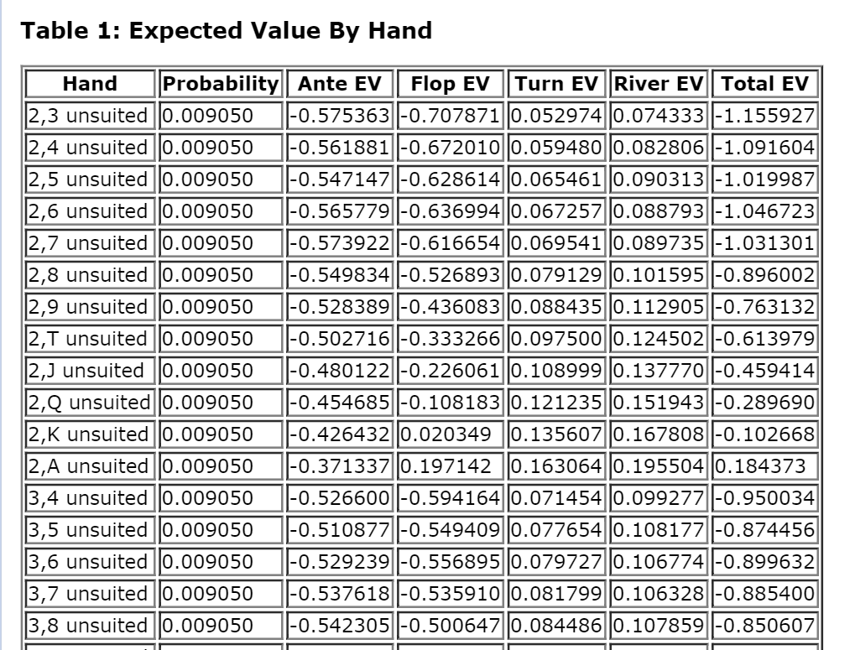

In fact, under each possible suit-permutation, we use MC simulation to calculate the expected value. So we can use MC simulation to calculate the whole house advantage and variance?

1. Expected value, house advantage and variance for the Bonus Bet is not changed whatever our strategy is.

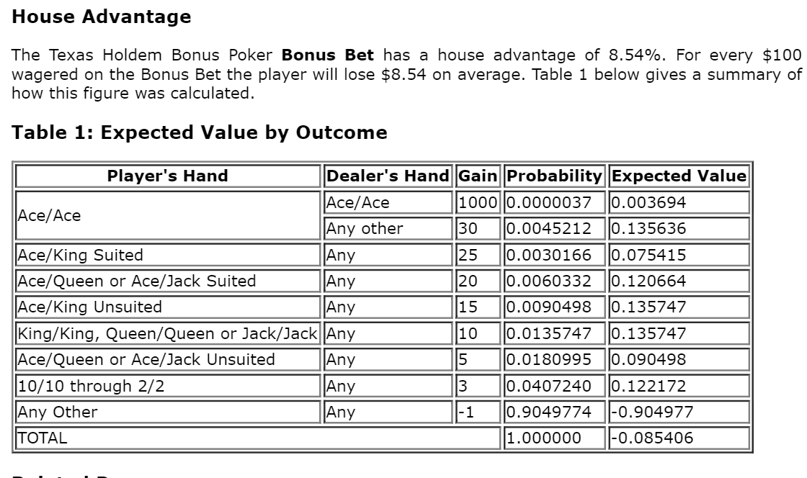

True?

1. Question about the non-standard conditions.

Player can identify other cards before the Bonus Bet or after? If before, it will affect the probability and expected value, variance of Bonus Bet. Notice that before Bonus Bet, player has no idea about his own holecards.

1. Code, loops???